**Name: Rutuja Dinanath Gaikwad**

**Assignment No 1**

1. **Navigate and List: a. Start by navigating to your home directory and list its contents. Then, move into a directory named "LinuxAssignment" if it exists; otherwise, create it.**

cdac@Rutuja:~$ pwd

/home/cdac

cdac@Rutuja:~$ cd

cdac@Rutuja:~$ ls

Feb25 LinuxAssignment

cdac@Rutuja:~$ cd LinuxAssignment

cdac@Rutuja:~/LinuxAssignment$

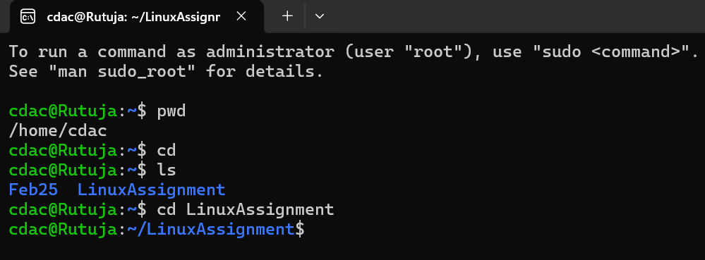

1. **File Management: a. Inside the "LinuxAssignment" directory, create a new file named "file1.txt". Display its contents.**

cdac@Rutuja:~$ cd LinuxAssignment

cdac@Rutuja:~/LinuxAssignment$ touch file1.text

cdac@Rutuja:~/LinuxAssignment$ cat file1.text

cdac@Rutuja:~/LinuxAssignment$ nano file1.text

cdac@Rutuja:~/LinuxAssignment$ cat file1.text

this is file1

Rutuja

Gaikwad

CDAC Mumbai

Feb 2025

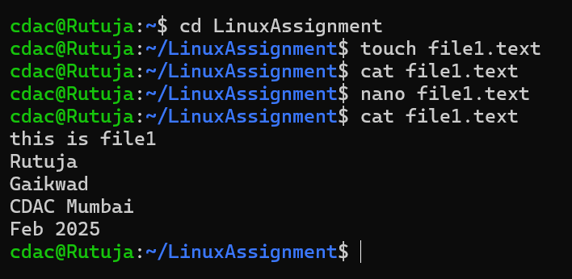

1. **Directory Management: a. Create a new directory named "docs" inside the "LinuxAssignment" directory**

cdac@Rutuja:~/LinuxAssignment$ cd ..

cdac@Rutuja:~$ cd LinuxAssignment

cdac@Rutuja:~/LinuxAssignment$ mkdir docs

cdac@Rutuja:~/LinuxAssignment$ ls

docs file1.text

cdac@Rutuja:~/LinuxAssignment$

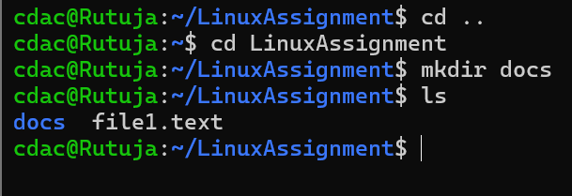

**h) System Information: a. Display the current system date and time.**

cdac@Rutuja:~/LinuxAssignment$ date

Thu Feb 27 08:40:39 IST 2025

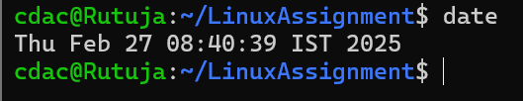

1. **Networking: a. Display the IP address of the system. b. Ping a remote server to check connectivity (provide a remote server address to ping).**

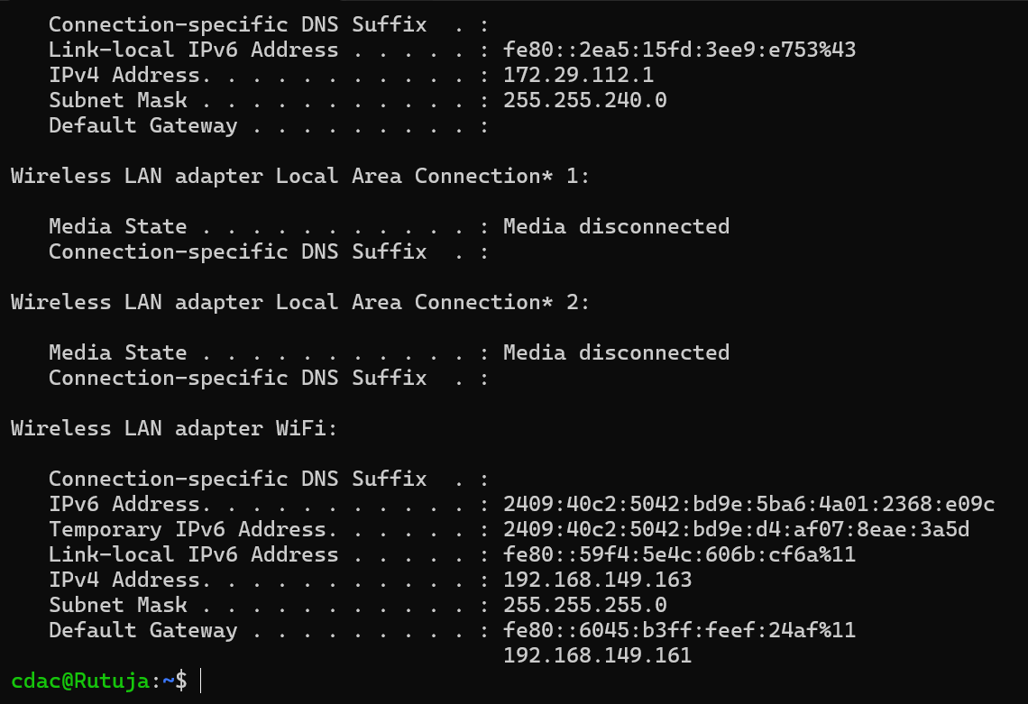

**e) Permissions and Ownership: a. Change the permissions of "file2.txt" to allow read, write, and execute permissions for the owner and only read permissions for others. Then, change the owner of "file2.txt" to the current user.**

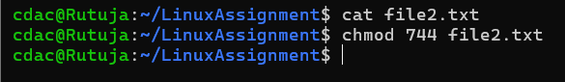

**f) Final Checklist: a. Finally, list the contents of the "LinuxAssignment" directory and the root directory to ensure that all operations wereperformance**

**correctly.** 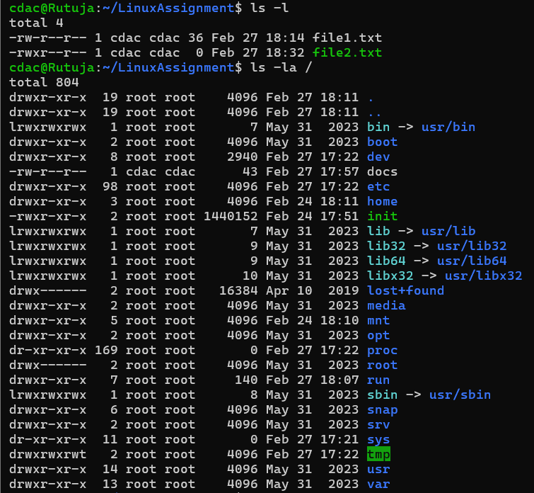

**g) File Searching:**

**a. Search for all files with the extension ".txt" in the current directory and its subdirectories.**

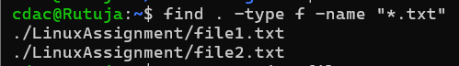

**b. Display lines containing a specific word in a file (provide a file name and the specific word to search).**

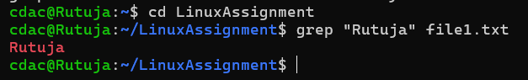

**j) File Compression: a. Compress the "docs" directory into a zip file. b. Extract the contents of the zip file into a new directory.**

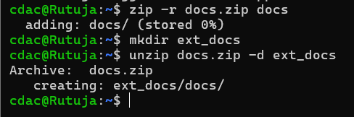

**k) File Editing:**

**a. Open the "file1.txt" file in a text editor and add some text to it**

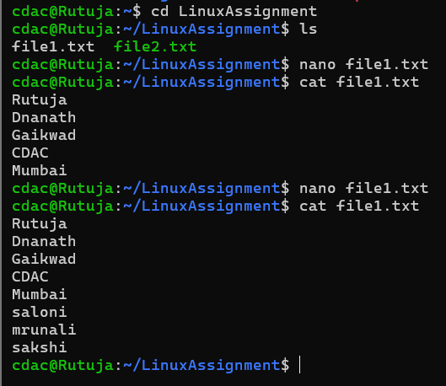

**b. Replace a specific word in the "file1.txt" file with another word (provide the original word and the word to replace it with).** 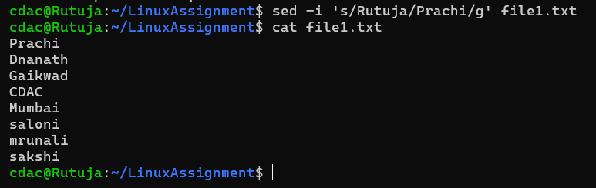

**a. Suppose you have a file named "data.txt" containing important information. Display the first 10 lines of this file to quickly glance at its contents using a command.**

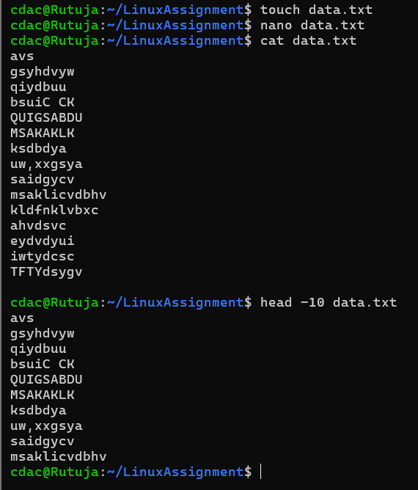

**b. Now, to check the end of the file for any recent additions, display the last 5 lines of "data.txt" using another command.**

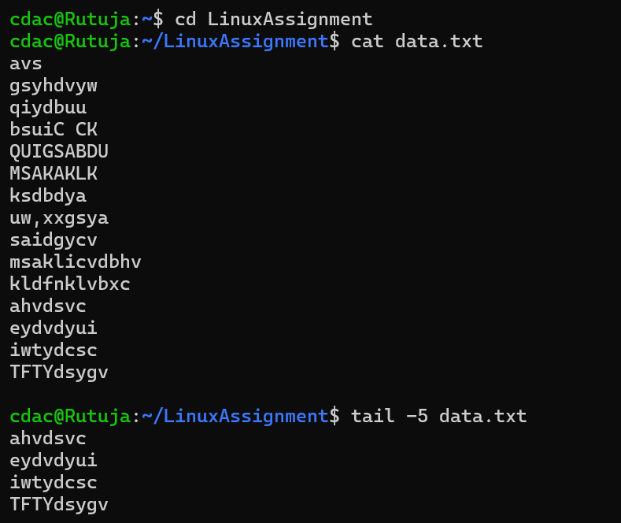

**c. In a file named "numbers.txt," there are a series of numbers. Display the first 15 lines of this file to analyze the initial data set.**

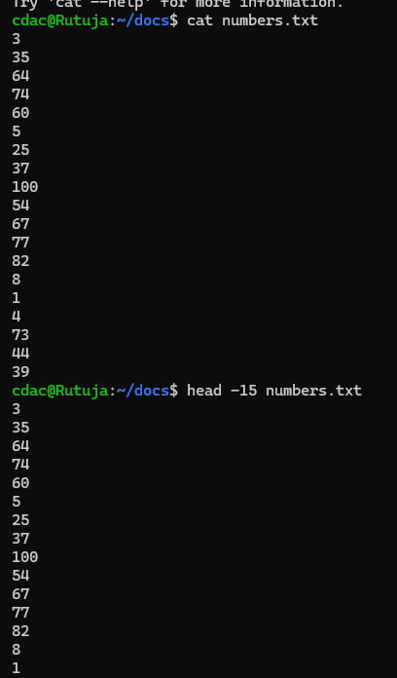

**d. To focus on the last few numbers of the dataset, display the last 3 lines of "numbers.txt"**

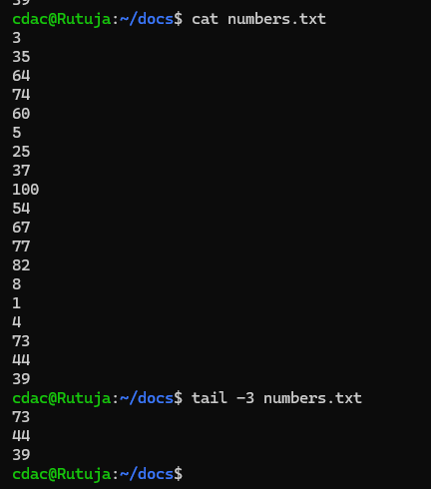

**e. Imagine you have a file named "input.txt" with text content. Use a command to translate all lowercase letters to uppercase in "input.txt" and save the modified text in a new file named "output.txt."**

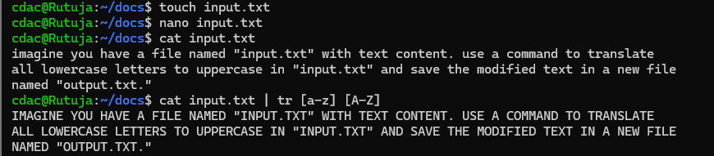

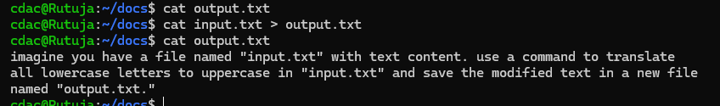

**f. In a file named "duplicate.txt," there are several lines of text, some of which are duplicates. Use a command to display only the unique lines from "duplicate.txt."**

